

MAPUA MALAYAN COLLEGES MINDANAO

SKIN DISEASE IDENTIFICATION THROUGH IMAGE CLASSIFICATION AND SEGMENTATION USING DEEP LEARNING TECHNIQUE

Andre Miguel C. Bacaling
Emmanuella Jester R. Casis
Joan S. Gumban

Bachelor of Science in Computer Science

Thesis Adviser
Ma’am Genevieve Pilongo
College of Computer and Information Science

SKIN DISEASE IDENTIFICATION THROUGH IMAGE CLASSIFICATION AND SEGMENTATION USING DEEP LEARNING TECHNIQUE

By

Andre Miguel C. Bacaling
Emmanuella Jester R. Casis
Joan S. Gumban

A Thesis Report Submitted to the College of Computer and Information Science
in Partial Fulfillment of the Requirements for the Degree

Bachelor of Science in Computer Science

Mapua Malayan Colleges Mindanao
Davao City

January 2023

APPROVAL SHEET

The thesis, entitled “SKIN DISEASE IDENTIFICATION THROUGH IMAGE CLASSIFICATION AND SEGMENTATION USING DEEP LEARNING TECHNIQUE” prepared and submitted by Andre Miguel C. Bacaling, Emmanuella Jester R. Casis, Joan S. Gumban in partial fulfillment of the requirements for the degree of Bachelor of Science in Computer Science is hereby accepted.

Genevieve Pilongo
(Signature over printed name)
THESIS ADVISER

Accepted as partial fulfillment of the requirements for the degree of BACHELOR OF SCIENCE IN COMPUTER SCIENCE

Rhodessa J. Cascaro, DIT
(Signature over printed name)
DEAN

ACKNOWLEDGEMENT
First, the proponents would like to express our deepest gratitude to the institution of Mapúa Malayan Colleges Mindanao, for allowing us to conduct this study within our community. The school has provided us with a world-class education and without that, we would not have been able to conduct this research.
We would also like to express our deepest appreciation to our Research Department Head, Dr. Gernelyn Logrosa. Her knowledge, dedication, and leadership skills have been pivotal in achieving the department’s goals and objectives. Her guidance and support towards us seniors allowed us to produce high-quality research that has made a significant impact on our field. We are thankful for her great contribution to our department and the research community as a whole.
To our dear adviser, Ma’am Genevieve Pilongo, we cannot thank you enough for your guidance in writing and developing our study. We are sincerely thankful for your support, motivation, and your willingness to help with our research paper. Thank you for believing in our capabilities to do this study. We could not have asked for a better research adviser. Without your help, this paper would not have been as feasible and comprehensive.
We also would like to express our deepest thanks to our panelists Sir Martzel Baste, Sir Patrick Cerna, and Sir Josh Dellosa, for providing us with valuable feedbacks and suggestions during our thesis defense.
We also would like to take this opportunity to express our deepest appreciation to our families and friends for their never-ending support, love, and understanding throughout the time of conducting this study.

Andre Miguel Bacaling
Emmanuelle Jester Casis
Joan Gumban
ABSTRACT
The biggest organ in the human body is the skin, and just like any other organ, the skin can also have problems. There are many different categories of skin problems, but this study will only focus on common viral skin infections, namely chickenpox, monkeypox, warts, corns, eczema, and warts. There are traditional methods for identifying viral skin infections. These include physical examinations in the affected area, studying the patient’s medical history, etc. These traditional methods for identifying skin infections can be time-consuming, costly, inaccurate, and unavailable in other areas of the world. The approach of this research is to provide a way of detecting these skin infections efficiently, accurately, and with little to no cost. It can be done through the use of Deep learning. The general purpose of this study is to detect some of the most common skin diseases through the use of deep learning techniques and by developing a predictive model from previous related studies. The study aims to develop a web-based application to visualize and test the model through image classification and segmentation using deep learning. Our dataset consists of around 1000 images collected from sources such as WHO, Kaggle, DermNet, and various websites which are dedicated to skin diseases and its cure to be more accurate and realistic. The data has been divided into two parts, the training augmented dataset and validation data. The augmented data is used to train our model and some of the validation data is used to check if our model is working efficiently or not. Our model predicts corns with 75% accuracy. Chickenpox is predicted with 99% accuracy. Eczema was predicted with 81% accuracy. Monkepox was predicted with 99% accuracy. Warts were predicted with 89% accuracy. This topic helps in the early identification and early treatment of diseases before they spread because most skin diseases can get spread easily with touch. This will help in the detection of skin diseases during a public health event and in some rural areas where there is already a lack of basic medical facilities.
TABLE OF CONTENTS
Title
Approval Sheet ii
Acknowledgments iii
Abstract
Chapter 1 - Introduction 1
1.1 Statement of the Problem 5
1.2 Background of the Study 5
1.3 Research Questions and Objectives 5
1.4 Theoretical Lens 5
1.5 Significance of the Study 5
1.6 Scope and Delimitations 5
Chapter 2 – Review of Related Literature 1
2.1 Skin Diseases 5
2.1.1 6
2.2 Image Classification in Skin Diseases 5
2.3.1 6
Chapter 3 - Methodology 1
3.1 Research Participants 5
3.2 Research Locale 5
3.3 Research Procedure 5
3.4 Data Collection 5
3.5 Resources and Model Description 5
3.6 Project Prototype 5
3.7 System Architecture 5
3.8 System Flow 5
3.9 IPO Model / Dataset Augmentation Process 5
3.10 Limitations of the Methodology 5
3.11 Trustworthiness of the Study 5
3.12 Ethical Considerations 5
Chapter 4 – Results and Analysis 1
Type chapter title (level 2) 5
Type chapter title (level 3) 6
Chapter 5 – Conclusion, Recommendations & Implications 1
Type chapter title (level 2) 5
Type chapter title (level 3) 6
References 1
Appendix A 1
Appendix B 1
Appendix C 1
Appendix D 1
Appendix E 1
Glossary 1

LIST OF TABLES
Table 1. ML Algorithms used by Previous Research
Table 2. Types of Skin Problems Included in Previous Research
Table 3. Skin Disease Dataset

LIST OF FIGURES
Figure 1. Agile Methodology
Figure 2. Process flow of classification algorithm Resnet
Figure 3. Project UI
Figure 4. Home Screen
Figure 5. Analysis Cases Screen
Figure 6. World Health Organization Viral Skin Diseases Analysis Case Screen
Figure 7. Contact Screen
Figure 8. System Architecture
Figure 9. System Flow
Figure 10. Data Augmentation Process
Figure 11. Image Processing Optimization and Feature Extraction
Figure 12. Fine-tune a pre-trained neural network model
Figure 13. Classification Model Result

LIST OF ABBREVIATIONS
DOH - Department of Health
CNN - Convolutional Neural Network
RESNET - Residual Network
SVM - Support Vector Machine
VGG – Visual Geometry Group

Article 1
SKIN DISEASE IDENTIFICATION THROUGH IMAGE CLASSIFICATION AND SEGMENTATION USING DEEP LEARNING TECHNIQUE

Andre Miguel C. Bacaling, Emmanuella Jester R.Casis, Joan S. Gumban

ªCollege of Computer and Information Science, Mapúa Malayan Colleges Mindanao, Davao City, Philippines 8000

Emails: amBacaling@mcm.edu.ph, ejCasis@mcm.edu.ph, jGumban@mcm.edu.ph

*Corresponding author
College of Computer and Information Science
Mapúa Malayan Colleges Mindanao
Gen. Douglas MacArthur Hwy, Talomo
Davao City, Philippines

Chapter 1 - Introduction
  - Statement of the Problem
The biggest organ in the human body is the skin, and just like any other organ, the skin can also have problems, such as cradle cap rashes from newborn babies to age spots in elders. There are many different categories of skin problems. There are skin discolorations, chronic skin conditions, skin cancers, acute skin problems, and viral skin infections. This study will focus more on viral skin infections. Globally, millions of individuals are afflicted by the widespread and incapacitating group of viral skin infections. These infections can appear in many different forms, including warts, cold sores, monkeypox, shingles, chickenpox, etc. Viral skin infections arise because they are manifested by pathogens such as HPV, Herpes simplex virus, and varicella-zoster virus. Skin disease and infections are more prevalent in developing countries and tropical climates. In the Philippines, viral skin infections are also prevalent. The most common infections that can be found in the Philippines include warts, eczema, and psoriasis. Locally, Davao City also has reports of chickenpox and measle outbreaks. These skin infections have different traits of what they can do to the human body. It can be a mild irritation or even a severe condition. Some are even highly contagious and could be at risk of an outbreak. This study aims to provide a way to identify them early on to avoid or prevent an outbreak from happening, and that is through the help of technology and the use of Machine Learning. In recent years, Machine Learning has become a powerful tool for image classification and analysis. It is widely used to solve real-world problems, including in the medical field. This thesis study aims to utilize deep learning techniques, a subset of Machine Learning, to detect viral skin lesions through image processing and classification, an accurate, and efficient tool for healthcare facilities and patients.
1.2 Background of the Study
There are traditional methods for identifying viral skin infections. These include physical examinations in the affected area, studying the patient’s medical history, and performing lab tests such as PCR tests, and serological tests. There is also a method wherein it involves scraping off a small part of the affected skin and then examining it under a microscope. These traditional methods for identifying skin infections can be time-consuming, costly, inaccurate, and unavailable in other areas of the world. The approach of this research is to provide a way of detecting these skin infections efficiently, accurately, and with little to no cost. It can be done through the use of Deep learning.
Deep learning is a subset of machine learning. Relatively, it is a new technology that has been proposed as a tool for diagnosis and classifying various medical conditions. These include skin diseases. In recent years, research papers such as “Early Detection of Skin Cancer - Solution for Identifying and Defining Skin Cancers using AI” (N. Darapaneni et al. 2022) and "Improvement of Skin Cancer Detection Performance Using Deep Learning Technique” (F. Yilmaz et al. 2020) are some of the several studies that have used deep learning as a means of diagnosing skin cancers. In the case of viral skin infections, its application of deep learning is a relatively recent area of study. However, there is already some research about the application of deep learning for identifying viral skin infections such as “A Deep Learning Based Framework for Diagnosing Multiple Skin Diseases in a Clinical Environment” by Yu-Zhu et al. 2021 and “Skin Disease Detection for Kids at School Using Deep Learning Techniques” by Manal Alghieth, 2022. In those studies, a deep learning model is often trained on a dataset of skin disease images, its diagnostic performance is compared to that of human experts. Convolutional Neural Networks (CNNs), which are deep learning architectures particularly well adapted for image classification problems, are frequently used in investigations. The main goals of these studies are to evaluate the diagnostic precision and accuracy of deep learning models for viral skin infections and to ascertain if they can be applied as diagnostic tools in clinical settings. Although deep learning has shown potential in diagnosing skin conditions, such as skin cancer detection using deep learning techniques by Dildar et al. 2021, additional study is required to assess how well it performs in the detection of viral skin infections. It is also crucial to note that before these models for identifying skin infections can be utilized as a diagnostic tool, their accuracy has to be confirmed in bigger and more varied patient populations as well as in real-world clinical settings.
The tables below show the differences between the previous related research articles based on what model and algorithm they have utilized, and what skin problems they have included as their dataset.
 |  | Models and Algorithms Used
No. | Research Title | EfficientNet-b4 | Inception-v3 | ResNet-50 | VGG-19 | AlexNet | SVM | Others (KNN, DT, etc.)
1. | A Deep Learning Based Framework for Diagnosing Multiple Skin Diseases in a Clinical Environment | ✔ | ✔ |  |  |  |  | ✔
2. | A machine learning approach for skin disease detection and classification using image segmentation |  |  |  |  | ✔ | ✔
3. | Skin Disease Detection for Kids at School Using Deep Learning Techniques |  |  |  | ✔
4. | Skin Disease Detection Using Deep Learning |  |  | ✔ |  |  | ✔ | ✔
Table 1. ML Algorithms used by Previous Research
 |  | Skin Problems Used
No. | Research Title | Monkeypox | Chickenpox | Corns | Eczema | Warts | Others
1. | A Deep Learning Based Framework for Diagnosing Multiple Skin Diseases in a Clinical Environment |  |  |  | ✔ | ✔ | ✔
2. | A machine learning approach for skin disease detection and classification using image segmentation |  |  |  |  |  | ✔
3. | Skin Disease Detection for Kids at School Using Deep Learning Techniques |  | ✔ |  |  | ✔ | ✔
4. | Skin Disease Detection Using Deep Learning |  |  |  | ✔ |  | ✔
Table 2. Types of Skin Problems Included in Previous Research
Table 1 shows that each research article used different types of pre-trained models. Some also created their model or modified the pre-trained models to achieve better results. In this study, the researchers will be using the ResNet-152 pre-trained model as only a handful of research about skin disease detection have had it and it is also one of the models that provide high accuracy in image classification. Table 2 shows the different types of skin problems that are included in the said research articles. The table also shows that these articles focused more on other skin problems, specifically the different types of skin cancers. In this study, the research will only focus on viral skin infections, a different category of skin problems.
  - Research Questions and Objectives
The general purpose of this study is to detect some of the most common skin diseases through the use of deep learning techniques and by developing an improved or modified predictive model from previous related studies.
Specifically, it intends to answer the following questions:
- What deep learning techniques can best apply in image classification and segmentation to identify skin diseases?
- What platform is best used for implementing these deep learning techniques?
- What is the accuracy of the algorithm developed in terms of identifying a skin disease?
The study aims to develop a web-based application to visualize and test the model through image classification and segmentation using deep learning.
Specifically, this study aims to:
1. Develop a responsive web-based application with the integration of a pre-trained model made by a convolutional neural network architecture algorithm.
2. Use FastAI to implement deep learning.
3. Determine the accuracy of the model by comparing its results with actual data.
1.4 Significance of the Study
This study will be undertaken to develop a soft web application that can analyze the uploaded image of the user and classify whether the patient potentially has a viral skin infection or not. This study will benefit the following:
Medical Team. This study will help the medical team to classify whether the patient has the virus.
Other Researchers. This study will add to the body of knowledge that other researchers can use as a reference for a similar study.

Chapter 2 – Review of Related Literature
2.1 Skin Diseases
Skin disease is just one of the many diseases in the world that affects millions of people worldwide. In this study, the researchers will create an application to detect skin diseases particularly monkeypox, chickenpox, warts, eczema, and corn.
According to the World Health Organization, monkeypox occurs in central and west Africa and has increasingly appeared in urban areas. The first case of monkeypox was identified in humans in 1970 in Congo. The first case identified outside Africa was in the United States of America and it was linked to contact with infected pet prairie dogs.
Another viral skin disease is chickenpox. Chickenpox is caused by the varicella-zoster virus that belongs to the a-herpes family. The virus is highly infectious, and it is contracted through person-to-person contact. Even though chickenpox and monkeypox both have “pox” in their names, the said diseases are different and caused by unrelated viruses. Chickenpox is caused by the varicella-zoster virus while monkeypox is caused by the monkeypox virus, a memberthe of orthopoxyvirus genus in the family Poxiridae.
The third skin disease is called warts. Warts are caused by HPV or known as human papillomavirus. The virus is contagious, and people can get warts from touching someone who was them. It commonly appears on the hands, but it can also appear on the feet, face, genitals, and knees. Most warts go away after the immune system fights off the virus but some warts cause issues like cancer, disfigurement, infection, and pain. Genital warts are linked to different cancers like cervical cancer and anal cancer (Cleveland Clinic).
The fourth skin disease is called eczema. It is a condition where the skin becomes dry, itchy, and bumpy. According to National Eczema Association, more than 31 million Americans have eczema. It can begin during childhood, and it can range from mild to severe. There is no cure for eczema but there are treatments that can help manage and minimize the symptoms.
The fifth skin disease is corns. It is a thick, hardened layer of skin that develops when the skin protects itself from pressure. Some people distinguish corns and calluses as the same, but they are different. Corns are smaller and deeper than calluses and they are also painful when pressed (Mayo Clinic).
According to Skin MD, skin diseases have low mortality rates, but they can be an indicator of underlying medical conditions and may also lead to health complications if not treated. The most common skin diseases in the Philippines are warts, eczema, hair, and nail problems.
2.2 Skin Diseases Using Image Classification
Skin disease detection is being studied by many researchers in line with machine learning, deep learning models, and image processing.
Many researchers made skin disease detection studies with different algorithms and deep learning models. A study by Algeith (2022) entitled “Skin Disease Detection for Kids at School Using Deep Learning Techniques” used the CNN technique and a pre-trained VGG19 model to detect skin disease. VGG19 model is a CNN that is 19 layers deep. It is the most used image-recognition architecture, and it proves to have a high accuracy result. The study by Algeith achieved a high accuracy of 99%.
Albishry et. All in 2022 applied MobileNetV2 and LSTM to develop a skin disease classification system. Based on the result of the project, the model surpassed other techniques and models to detect skin diseases.
A study by Al Shabibi and Koottala used Matlab to detect acne, cancer, and psoriasis dermatitis. They also utilized SVM to identify the symptoms of the three skin diseases to improve the identification accuracy.
The research by Ahammed et. Al entitled “A machine learning approach for skin disease detection and classification using image segmentation” introduced a digital hair removal technique. They also applied the automatic Grabcut segmentation technique to segment the affected lesions. Three machine learning techniques, Decision Tree, SVM, and KNN were used to classify the skin images. The models of this study were validated using two datasets ISIC 2019 challenge and HAM10000. The result shows that SVM performs better than the two classifiers.
A study by Christian Szegedy et al. in 2015 entitled Skin Lesion Analysis Towards Melanoma Detection: A Challenge at the 2017 International Symposium on Biomedical Imaging (ISBI).
In this study, the authors used the Inception v3 model as a feature extractor for images of skin lesions and then trained a simple linear classifier on top of the extracted features to classify the images as either benign or malignant. The study participated in the ISBI 2017 challenge on skin lesion analysis and achieved state-of-the-art performance, outperforming other methods that used more complex architectures or additional data. The study showed that using a pre-trained model such as Inception v3 can be a good choice for skin lesion classification tasks, as the model has already learned features that are useful for image classification in general.

A study Skin Lesion Analysis Towards Melanoma Detection "Skin Lesion Analysis Towards Melanoma Detection: A Challenge at the 2017 International Symposium on Biomedical Imaging (ISBI)"
In this study, the authors used a DenseNet-121 architecture and trained it on the ISIC 2017 Challenge dataset. They achieved an overall accuracy of 87.4% on the test set, which was among the top results in the competition. Another study is "Densely Connected Convolutional Networks for Skin Lesion Analysis" in which they used DenseNet-169 architecture and achieved an accuracy of 89.2%. These studies demonstrate the potential of using DenseNet for skin lesion classification.

A study by De Goma and Devaraj (2020) entitled Recognizing Common Skin Diseases in the Philippines Using Image Processing and Machine Learning Classification.

In this study, the proponents created a system that detects acne vulgaris, atopic dermatitis, keratosis pilaris, psoriasis, leprosy, and warts using different pre-processing and segmentation algorithms. The proponents used the SVM classifier and Artificial Neural Network classifier to train the model. For the SVM classifier, the model accomplished an average of 93.55% and 93.33% for precision and recall and for the ANN classifier, it accomplished an average of 96.55% and 100% for precision and recall.

Chapter 3 – Methodology
3.1 Research Participants
The participants in this research will be any of the users who would like to test the output of this project. This also includes doctors and physicians. They will be testing the validity of the application.
3.2 Research Locale
The research will take place in Davao City, Philippines. The researchers will also try to gather images of viral skin infections coming from the Department of Health Region XI, which is to be included in the dataset.
3.3 Project Procedure
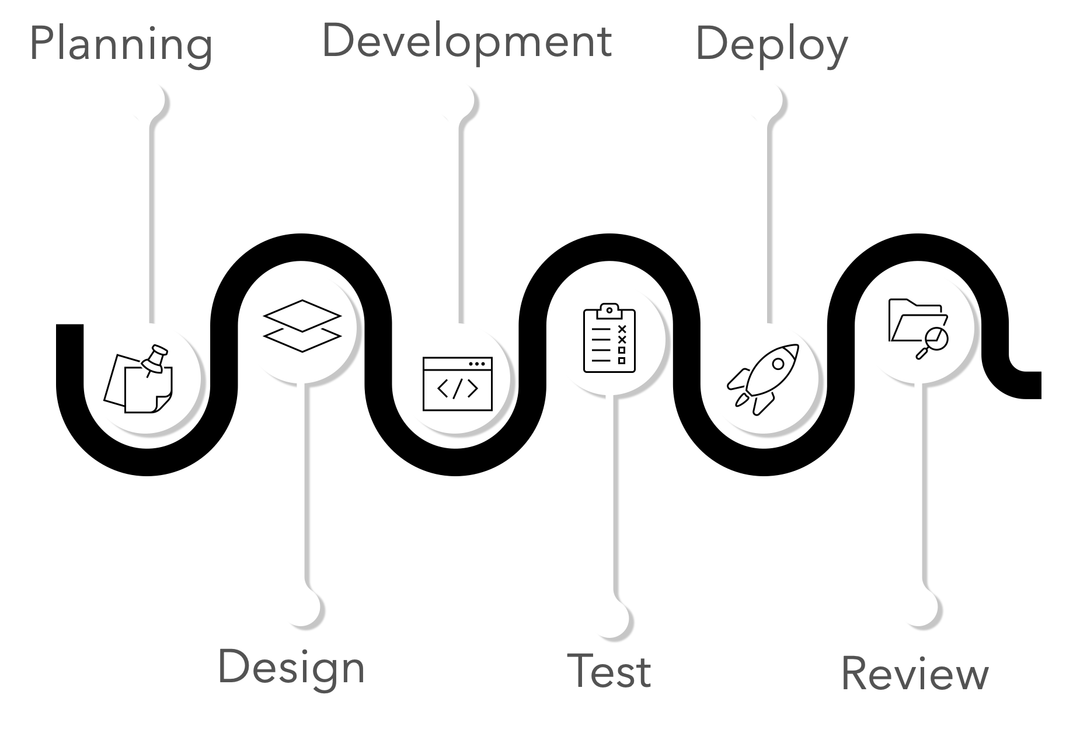
Figure 1: Agile Methodology
Planning
The planning phase is the phase wherein the researchers discussed the approach of the research, such as what tools are needed to develop the application, and where to find reliable image datasets for the model to learn.
Design
In this phase, the researchers designed a prototype of their website, what the app should look like, and what functionalities it should have. This is also the phase where the researchers made the initial manuscript.
Development
In this phase, this is where the design was put into action. The researchers started to develop the website. The researchers started to make the front end and develop the back end.
Test
The testing phase is where the model training and model evaluation takes place. In this phase, the researchers tested the system to check if there are any bugs or errors in the application.
Deploy
The deployment phase is where the developed system is ready to be deployed and hosted to a web server for the public to use. In this phase, the application is ready for deployment.
Review
After the system is deployed, this is the phase where reviewing will take place. The researchers will be evaluating the performance of the application, how well it performs, and if there is a need to have changes.
3.4 Data Collection
Our dataset consists of around 1000 images collected from a lot of sources WHO, Kaggle, DermNet, and various websites which are dedicated to skin diseases and its cure to be more accurate and realistic. The data has been divided into two parts the training augmented dataset and validation data. The augmented data is used to train our model and some of the validation data is used to check if our model is working efficiently or not. The data we have collected is categorized into different sections based on the types of illnesses they represent. We have included viral diseases, which have been prevalent worldwide.
Disease | Sample Images | Number of Images
Monkeypox | 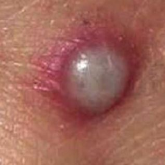 | 279
Corns | 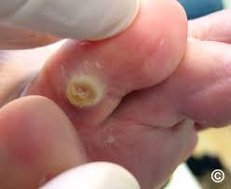 | 36
Eczema | 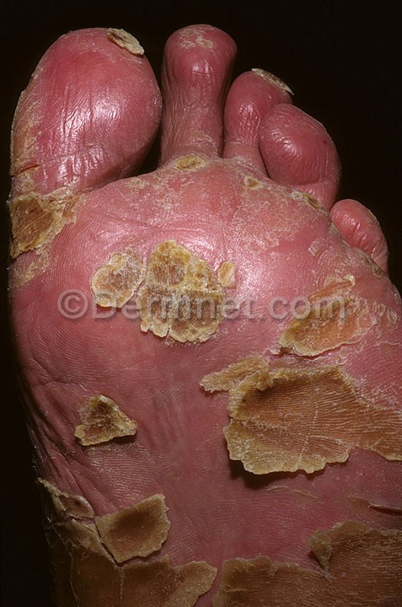 | 180
Chickenpox | 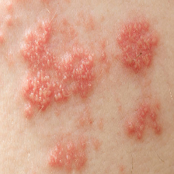 | 107
Warts | 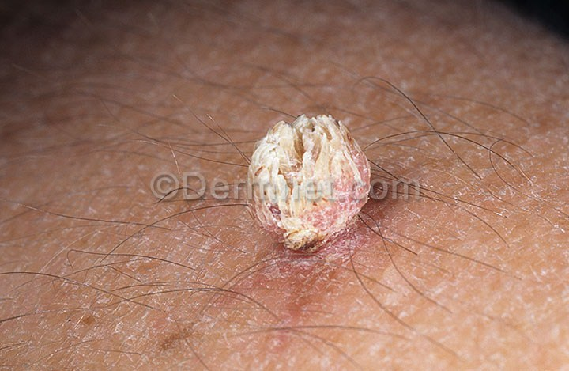 | 101
Table 3: Skin Disease Dataset
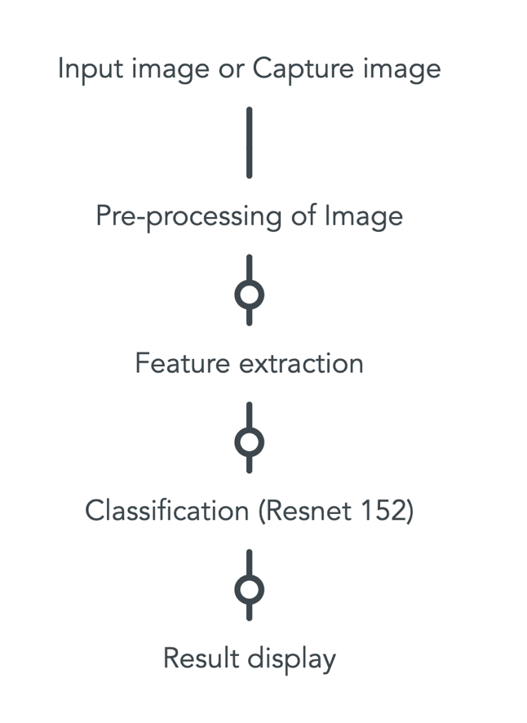
Figure 2: Process flow of classification algorithm Resnet
Figure 3 shows the process flow of the classification algorithm using Resnet. The input skin image is taken from patients who have the disease. The pre-processing includes resizing the image into accurate directions and we a add gaussian noise function. For the feature extraction of the image, we use an algorithm that will work on various layers of the image for the feature extraction from the image. This requirement leads us to using the Resnet 152 layers algorithm. The results are displayed in the application itself.
Preprocessing
To achieve a high accuracy of skin diseases detection and prediction we are required to overcome a few problems. We tried training with the original dataset, but the result is poor. Our dataset is imbalanced. So, we decide down sample to ~ 1000 samples in each class and add gaussian noise of each image. of 2 involves discarding every other pixel in both the horizontal and vertical dimensions. We Create dataset.csv and labels.csv based on the Argumented dataset.
Feature Extraction
To extract features from an image, we need an algorithm that can operate on different layers of the image. To achieve this goal, we have used Randoms liter for splitting the training and validation dataset and we performed item level transforms on input data to resize image to 224 pixels. Also, we performed batch level transforms to the input data I-E we applied a random resized crop of size 224 pixel using GPU. The detection of skin depends upon the gaussian noise pixel color ration of each pixel. The detection of skin depends upon pixels and Gaussian noise of each pixel.
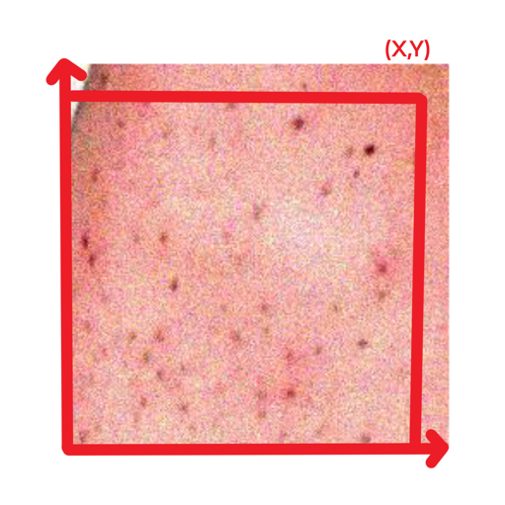
The XY values can be generated from the ration of gaussian noise for each pixel. And input into a formula. A(x,y) = H(x,y) + B(x,y) Where, A(x,y)= function of noisy image. H(x,y)= function of image noise , B(x,y)= function of original image.

The data I-E I(x,y) is an image function where I= Intensity at position (X,Y) in an image.
We Create data loaders for the training dataset to labeling groups of pixels of each image. Identification of the infected area helped our model to ease the prediction of our classifier to find the disease.
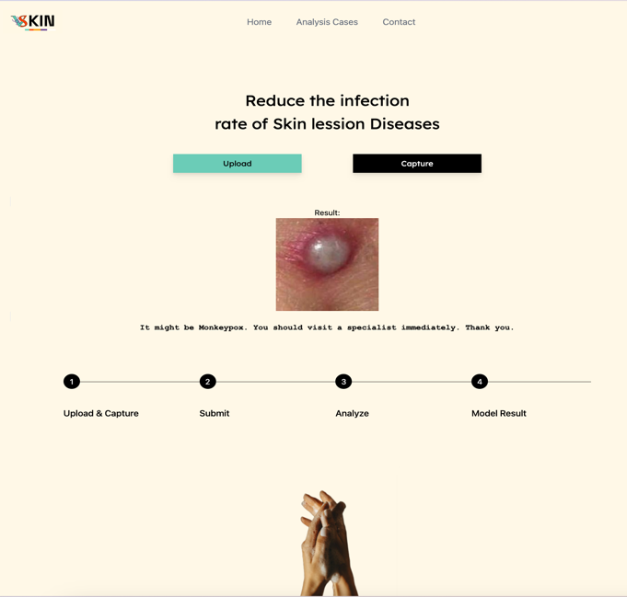
Classification
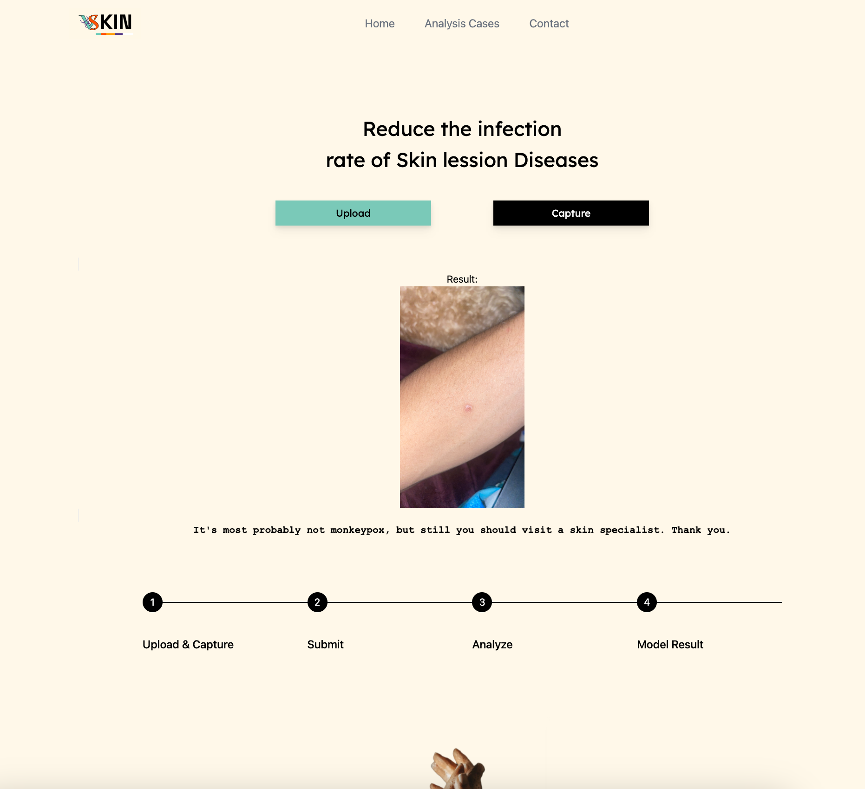
Figure 3: Detection Analysis of Chickenpox, Corns, Eczema, Monkeypox, Warts
The Convolutional Neural Network is fed with trained data which help in identifying the diseases. Feature are extracted from training dataset. A prebuilt model is used here to identify every layer’s pixel of the disease. In classification we use label smoothing technique for classification problems to prevenient the model from predicting the labels too confidently during training. And for optimization we use optimization function ranger.
3.5 Resources and Model Description
FastAI
Fastai is a library for deep learning that offers pre-built tools for practitioners to achieve high-quality results in common deep learning tasks with ease. It also provides researchers with customizable building blocks to develop new approaches without sacrificing usability, adaptability, or efficiency. Fastai achieves this through a layered architecture that uses abstract concepts to represent the fundamental patterns of various deep learning and data processing techniques. These abstractions are expressed clearly and briefly by utilizing the flexibility of the PyTorch library and the dynamic nature of the Python language. Fastai has its own advantages compared to other deep learning libraries and we can use it to build and train image processing on our model.
Fine-tuning
Fine-tuning is to leverage the knowledge learned from a pre-trained model and apply it to a new task. Fine-tuning can be done by adjusting the parameters of the pre-trained model or by training the entire model on the new dataset. It is a popular technique used to improve the performance of deep learning models, especially when the new dataset is small or similar to the original dataset used to train the model.

Flask
Flask is a micro web framework for python that allows developers to build web applications quickly and easily. The front-end of a Flask application refers to the part of the application that interacts with the user, such `as the HTML, CSS, and JavaScript that make up the user interface.
OpenCV (Computer Vision)
OpenCV is a powerful library for image processing, which is one of its primary focus areas. It provides a wide range of functions for image manipulation, including image filtering, thresholding, color space conversions, feature detection and extraction, and image alignment and registration.
3.6 Project UI
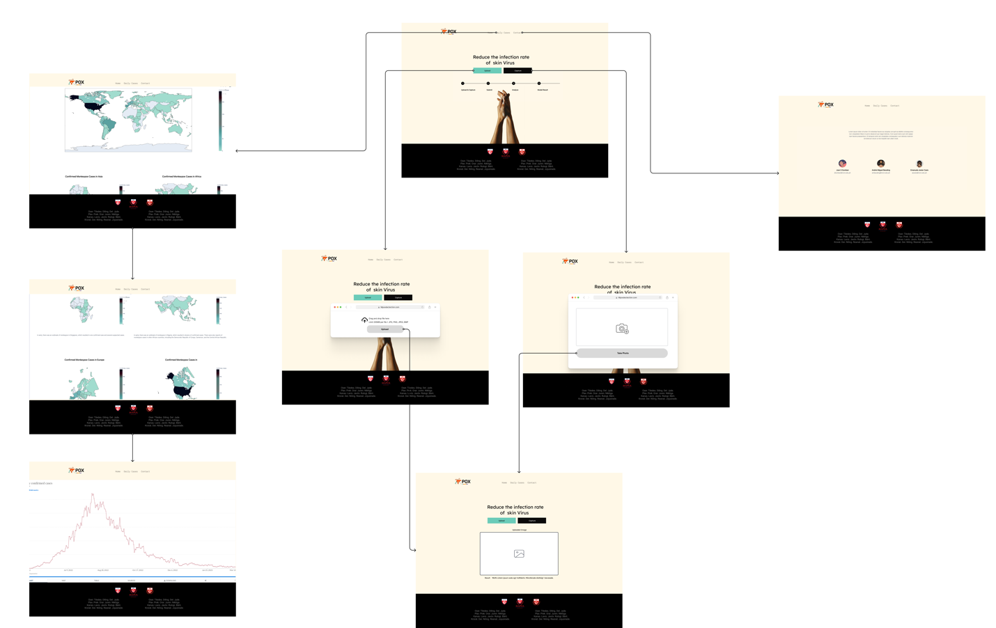
Figure 4: Project UI


Figure 5: Home Screen
Figure 4 shows the home screen of the disease’s detection. This screen appears when the application’s URL is entered, and it includes a system guideline for the user to view.

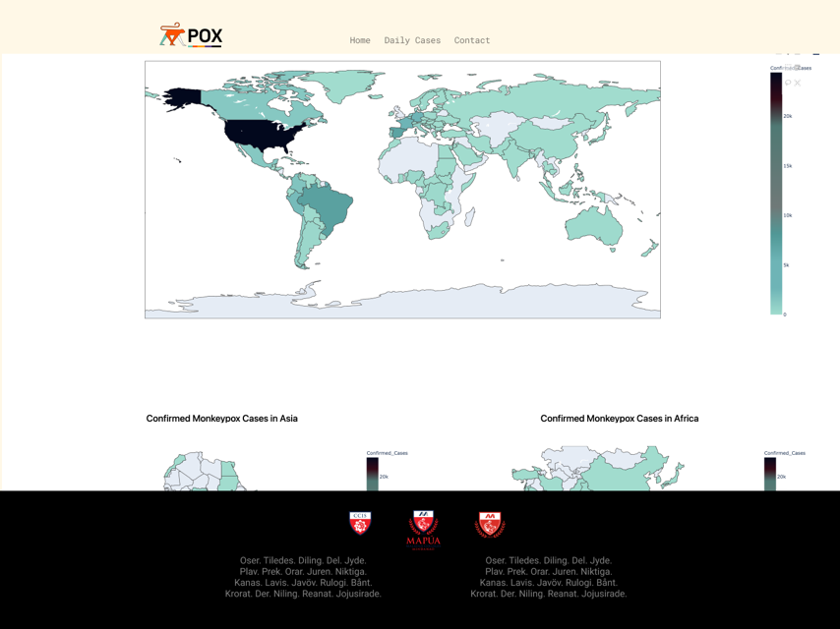
Figure 6: Analysis Cases Screen
Figure 5 shows the analysis cases. Our system has a feature that utilize the Global skin diseases dataset from Kaggle for the purpose of analyzing cases. We display these datasets using an oper-source library called plotly.js, which can be visualized in Jupiter notebook and integrated into our server.

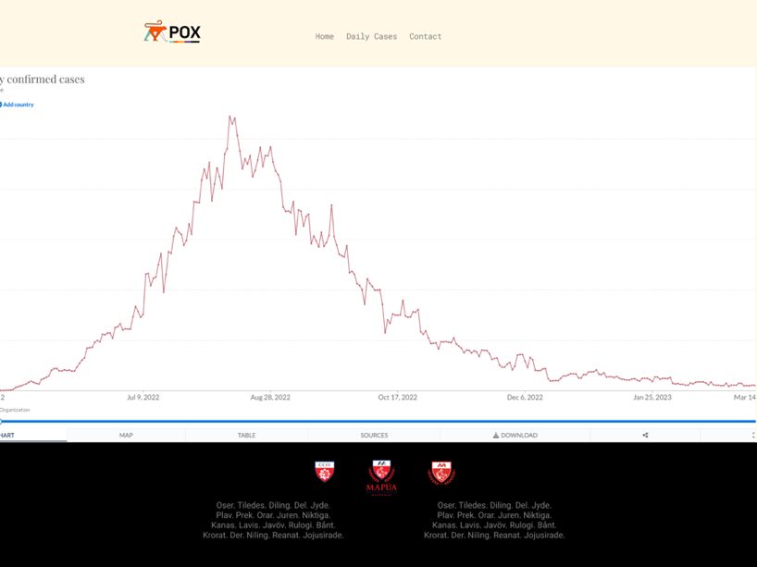

Figure 7: World health Organization Viral Skin Diseases Analysis Cases Screen

Figure 6 shows the World health Organization Viral Skin Diseases Analysis Cases. An HTML iframe element tag that embeds and interactive chart or table from the website ourworldindata.org. The chart is related to Viral diseases case today and displays confirmed cases data over time, with options to filter by various metrics such as frequency and relative population.

Figure 8: Contact Screen
Figure 7 shows the Contact Screen. This feature allows the user to view the developers of the application, making it easier for the user to reach out to them.

3.7 Conceptual Framework
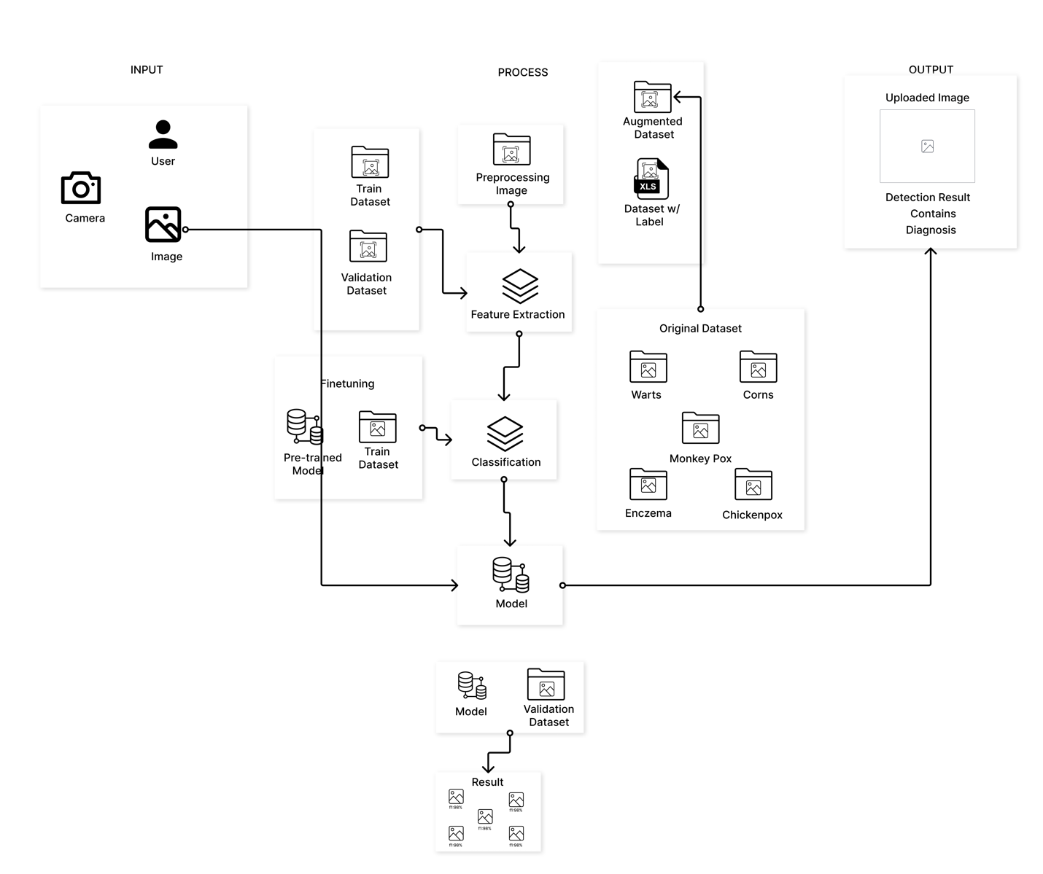
Figure 9. Conceptual Framework
Figure 4 shows the architecture of the application. As the user launches the app, it starts with a home screen. Users can see the guidelines which contain the process of how to use the application. In the home screen, the user can pick between the upload image button or the capture button. Both of these options have the same function: to identify what diseases the user has, it also shows the accuracy of the prediction and the Diagnoses.
3.8 System Flow
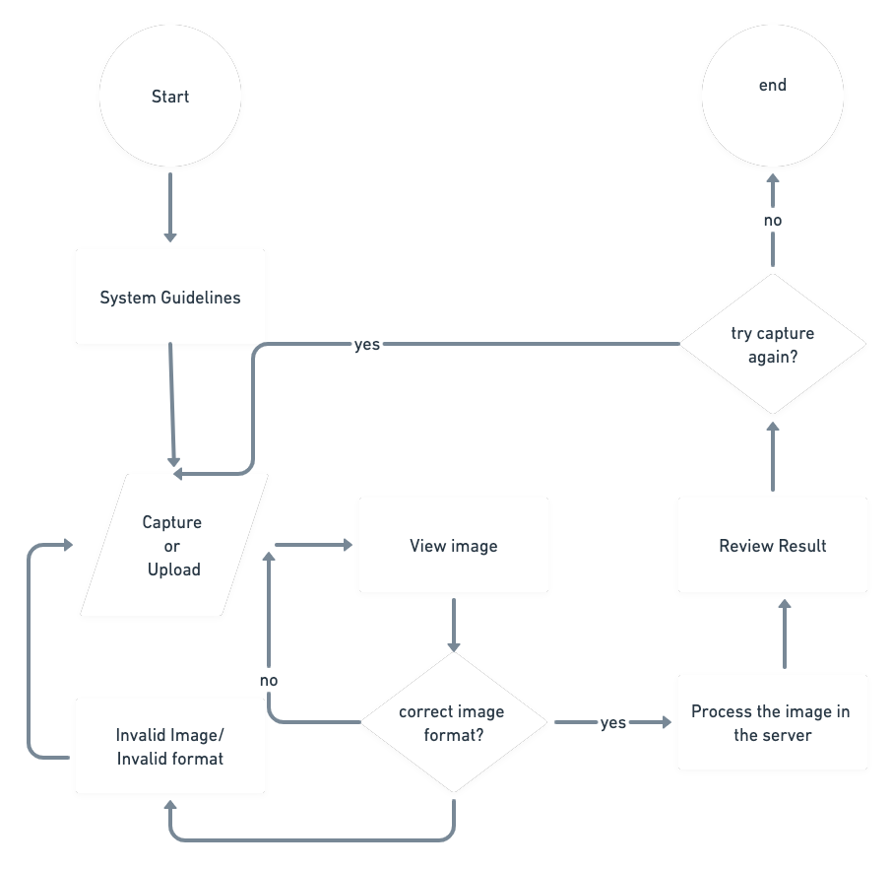
Figure 10. System Flow
Figure 10 is the flowchart for our system. It starts with the system guidelines, then it will lead you to an option to either upload an image from your device or capture an image using your device’s camera. If the image is the correct image format, it will be fed to the system’s server. Otherwise, it would not be accepted. After an image has been fed to the system, it will be sent to the server for it to be predicted and classified by our training model. After the process, the model’s classification and prediction rate will be shown to the user.

3.9 Data Augmentation Process
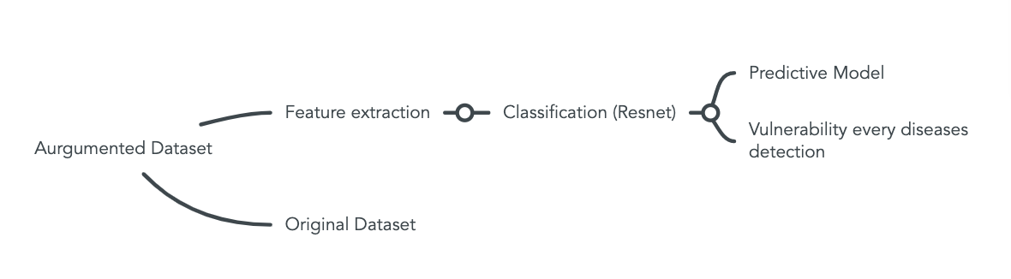
Figure 11. Data Augmentation Process
Figure 11 shows the Data augmentation process. Data augmentation is a technique that is used to increase the number or size of the training dataset. This is used when there is a lack of number of images in a dataset. The goal of augmenting image data is to create additional images that are similar to that of the original image, but have different characteristics, such as the scale, cropping, angle, and lighting of the image. This process can help improve the performance of the machine learning model.
The first step in data augmentation is loading the original image dataset that is stored in a directory. The next step is to define a pipeline of transformation to apply to our original images. In our case we created a function to add gaussian noise to the image. We also added transformations such as flipping the image vertically and horizontally and rotating the image in a specific angle. Once a transformation pipeline has been defined, the images are now ready to be augmented.
3.10 Limitations of Methodology
1. We utilized data augmentation and down-sampling techniques to reduce the number of samples in each class to around 1000, and as a result, we observed improvements in the f1 score.
2.. Initially we tried training with the original dataset, but it resulted in poor f1 score as the dataset was highly imbalanced.
3.11 Trustworthiness of the Study
The Reset and are pre-trained models that will be used to help identify different kinds of skin lesions. These pre-trained models are commonly used in image classification. The researchers are confident that these models will result in the intended outcome of this study.
3.12 Ethical Considerations
· Social Value
This study aims to help hospitals, specifically doctors, to identify patients with viral skin infection. The application can also be used during public health events in the community.
· Informed Consent
The researchers will send an email or any form of letter to the DOH office to request datasets regarding skin lesions.
· Privacy and Confidentiality
The dataset that will be used in this research will be strictly confidential. It will only be used to fulfill the purpose of this research.
· Adequacy of Facilities
This study will be conducted on devices that are always available to the researchers.
· Qualification of Researchers
The researchers are Computer Science students in Mapua Malayan Colleges Mindanao. They are qualified to conduct this study because they want to help the community in dealing with viral skin infections.

Chapter 4 - Results and Discussion
Initially, to optimize the skin image and our model training result, we apply some image processing methods by increasing our dataset using this function generates 10 new images for each input image, including the original image and image with various rotations, mirroring, and Gaussian noise. This technique can be useful for increasing the size of our data and improving our training result of the machine learning model.

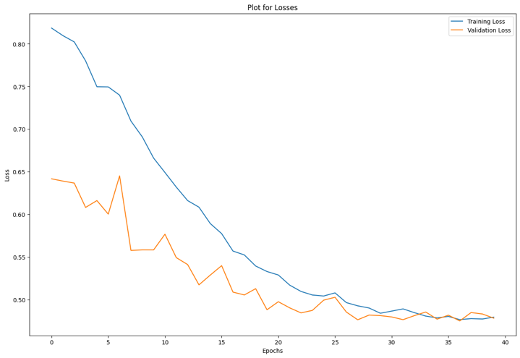
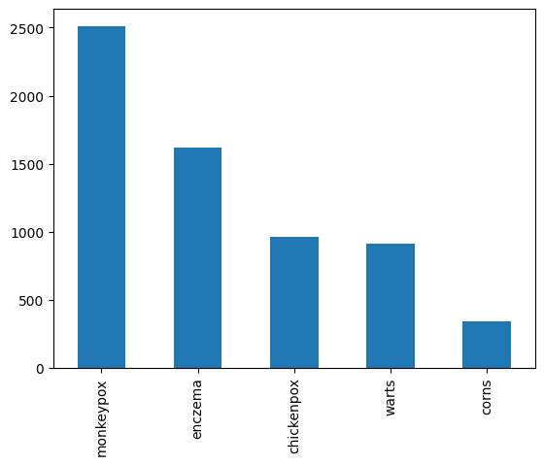

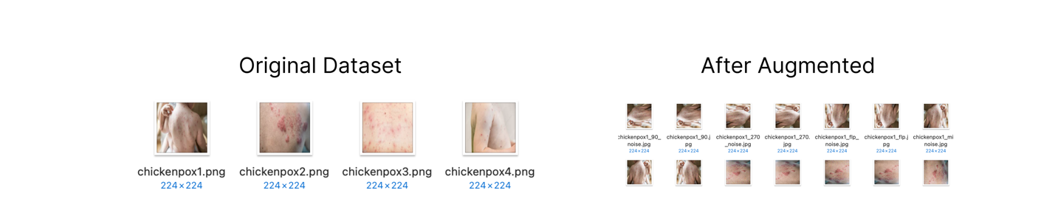
Figure 12. Image Processing Optimization and Feature Extraction
Figure 12 shows the data distribution after the images have been augmented. Monkeypox images have the greatest number of augmented images as it was the dataset with the greatest number of original images. Corns had the least number of augmented images because of the lack of original images.
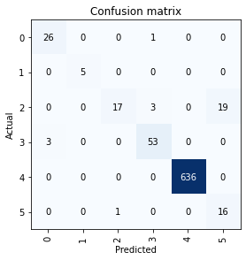
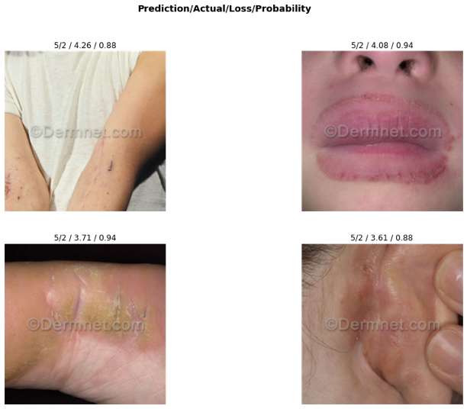
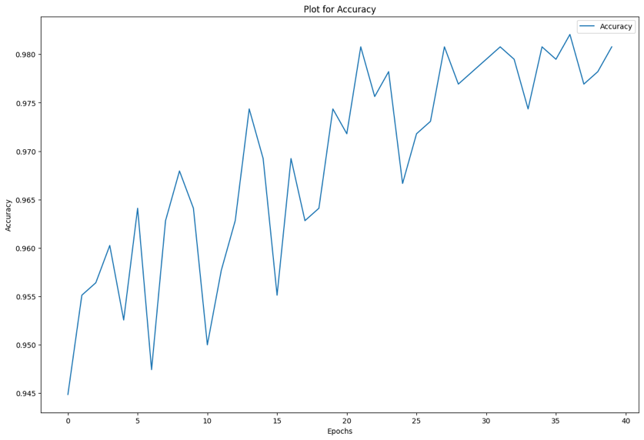

Figure 13. Classification Model Result
Figure 13 shows the result of our model’s classification of images. The confusion matrix above is a multi-class classification with 6 classes. Each class represents the skin types in the dataset (chickenpox, monkeypox, warts, eczema, corns, normal). The matrix shows the number of instances for each class that was classified correctly and incorrectly by our model. For example, the value of 26 in class 0 means there were 27 actual instances of class 0 in the test data, and the model predicted 1 of them as class 3 and 26 of them as class 0.
The Plot for Accuracy shows that the more epochs that you run for the model, the accuracy of the prediction goes higher as well. This is because the model learns from its mistakes and gets better and better after each epoch.

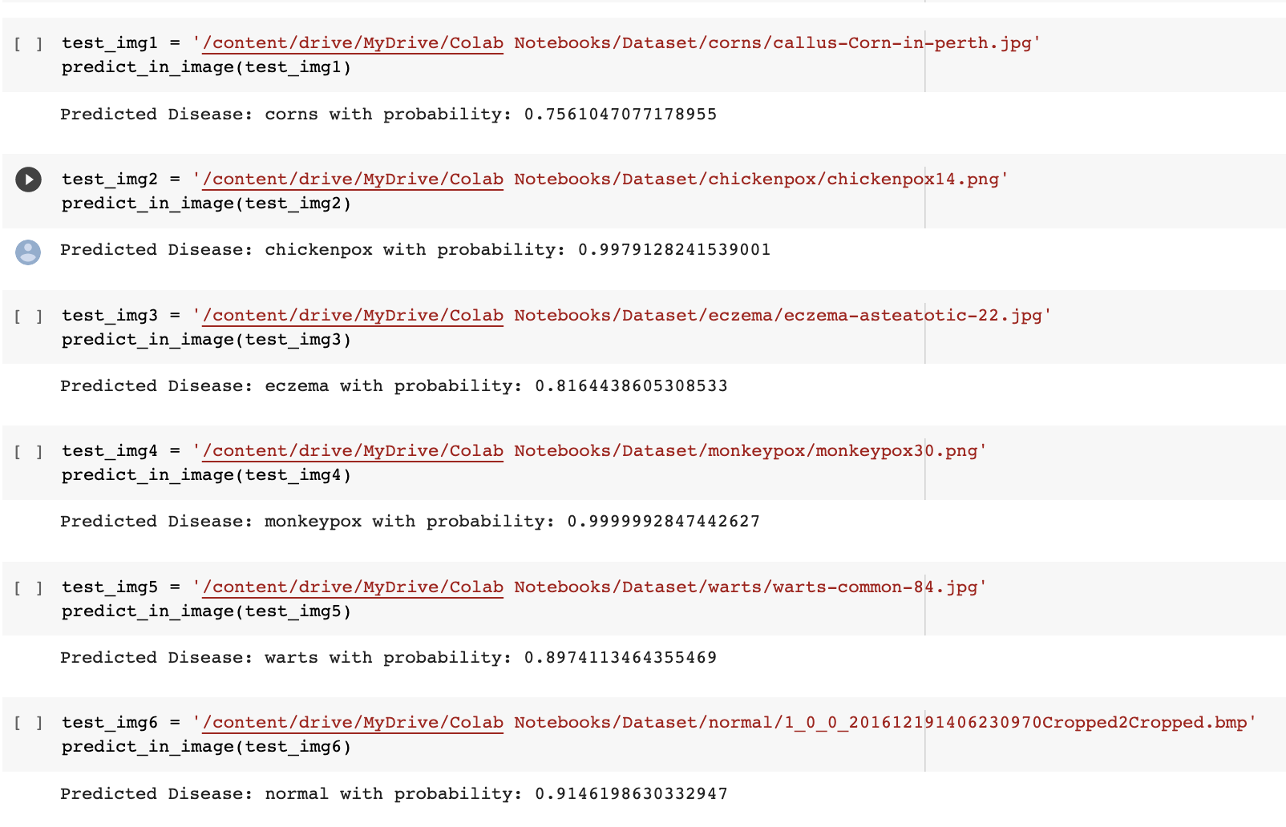
Figure 14. Rate of Skin Diseases Detection

Figure 14 shows the prediction results of the training data. The application predicts corns with 75% accuracy. Chickenpox is predicted with 99% accuracy. Eczema was predicted with 81% accuracy. Monkepox was predicted with 99% accuracy. Warts were predicted with 89% accuracy.

Research Title | Date | Technique | Accuracy
Skin Disease Identification Through Classification and Segmentation Using Deep Learning Technique | March 2023 | ResNet-152 | Monkeypox: 99%  Chickenpox: 99%  Warts: 81%  Eczema: 89%  Corns: 75%
A Deep Learning Based Framework for Diagnosing Multiple Skin Diseases in a Clinical Environment | April 2021 | EfficientNet-b4  Inception-v3 | 94%
A machine learning approach for skin disease detection and classification using image segmentation | (n.d) | SVM  KNN  DT | SVM: 95%  KNN: 94%  DT: 93%
Skin Disease Detection for Kids at School Using Deep Learning Techniques | July 2022 | VGG19 | 99%
Skin Disease Detection Using Deep Learning | 2022 | ResNet-50  SVM  Softmax classifier | 87%

Table 4. Comparison of Results

Table 4 shows the comparison between our research study and other related skin disease detection studies. The first study entitled Skin Disease Identification Through Classification and Segmentation Using Deep Learning Technique used ResNet-152. The accuracy for Monkeypox prediction is 99%, Chickenpox is 99%, Warts is 81%, Eczema is 89%, and Corns is 75%. The second study is entitled A Deep Learning Based Framework for Diagnosing Multiple Skin Diseases in a Clinical Environment. The proponents of this study used EfficientNet-b4 and Inception-v3 to classify skin diseases. The accuracy of the model is 94%. The third study is entitled A Machine Learning Approach for Skin Disease Detection and Classification using Image Segmentation. The technique they used to classify and detect skin disease was SVM, KNN, and DT. SVM can detect and classify skin disease by 95% while KNN can detect by 94% and DT by 93%. The next study is entitled Skin Disease Detection for Kids at School Using Deep Learning Techniques. The technique they used is VGG19 and it can detect skin disease by 99%. The last study is entitled Skin Disease Detection Using Deep Learning and they used ResNet-50, SVM and Softmax Classifier to detect skin disease. The study resulted to have 87% detection accuracy.

Chapter 5 - Conclusion and Recommendations
5.1 Conclusion
Based on the results of the study, the model that the researchers have developed showed promising results in classifying the group of viral skin infections that are in the dataset. It can predict the training data with 80-90+% accuracy. When it is fed with test images, there are cases where it can classify the correct skin infection. However, there are also cases wherein the prediction rate drops down to as low as 60% when it was fed with an image outside of the training data. The classifier can sometimes be inaccurate.
Our topic also helps in the early identification and early treatment of diseases before they spread because most skin diseases can get spread easily with touch. In our application, we have used a modified pre-trained model of the Convolutional neural network algorithm. This will help in the detection of skin diseases during a public health event and in some rural areas where there is already a lack of basic medical facilities. All in all, by using our technology, it is hoped that skin diseases can be detected and treated early before they can spread and cause further harm.
5.2 Recommendations
The study only focused on classifying five skin diseases particularly monkeypox, chickenpox, warts, eczema, and corns using ResNet-152 as our pre-trained model. However, there are other approaches to classifying skin diseases. These approaches could be used in future studies about classifying skin diseases.
Based on the results of this study, we recommend the future researchers to gather more images that are of high quality and are more focused on the appearance of the skin disease for the dataset. This in return will help lessen the inaccurate prediction of the model. The researchers would also recommend trying to utilize deep learning in detecting other skin diseases that are not mentioned in this study to further contribute to the growth and development of technology in the medical field and dermatology.

References:
Ahammed, Mostafiz, et al. “A Machine Learning Approach for Skin Disease Detection and Classification Using Image Segmentation.” Healthcare Analytics, vol. 2, Nov. 2022, p. 100122, 10.1016/j.health.2022.100122. Accessed 13 Nov. 2022.
Al Shabibi, Ismail Saif Sulaiman, and Sreedevi Koottala. “Detection of Skin Diseases Using Matlab.” Journal of Student Research, 13 July 2020, 10.47611/jsr.vi.884. Accessed 11 Nov. 2021.
Alghieth, Manal. “Skin Disease Detection for Kids at School Using Deep Learning Techniques.” International Journal of Online and Biomedical Engineering (IJOE), vol. 18, no. 10, 26 July 2022, pp. 114–128, 10.3991/ijoe.v18i10.31879. Accessed 31 Aug. 2022.
Goma, Joel CASUAYAN DE, and M. Devaraj. “Recognizing Common Skin Diseases in the Philippines Using Image Processing and Machine Learning Classification.” 2020 the 3rd International Conference on Computing and Big Data, 2020, www.semanticscholar.org/paper/Recognizing-Common-Skin-Diseases-in-the-Philippines-GOMA-Devaraj/7506c3905d8ccc13c94cc9a4b4ca1e7cdd894e42. Accessed 18 Jan. 2023.
Guardian News and Media. (2013, June 8). Ask a grown-up: How did the first person catch chickenpox? The Guardian. Retrieved March 30, 2023, from https://www.theguardian.com/lifeandstyle/2013/jun/08/ask-grown-up-chickenpox#:~:text=than%20human%20beings.-,The%20first%20chickenpox%20viruses%20probably%20emerged%2070m%20years%20ago%2C%20around,viruses%20have%20evolved%20with%20us.
JOEL CASUAYAN DE GOMA Mapua University, Goma, J. C. D., University, M., University, M. D. M., Devaraj, M., University, M., Contributor MetricsExpand All Joel Casuayan de Goma Mapúa University Publication Years2020 - 2020Publicati, &amp; Joel Casuayan de Goma Mapúa University Publication Years2020 - 2020Publication counts1Available for Download1Citation count1Downloads (cumulative)237Downloads (6 weeks)3Downloads (12 months)91Average Citation per A. (2020, August 1). Recognizing common skin diseases in the Philippines using image processing and machine learning classification: 2020 the 3rd International Conference on Computing and Big Data. ACM Other conferences. Retrieved March 30, 2023, from https://dl.acm.org/doi/fullHtml/10.1145/3418688.3418700
Kshirsagar, Pravin R., et al. “Deep Learning Approaches for Prognosis of Automated Skin Disease.” Life, vol. 12, no. 3, 15 Mar. 2022, p. 426, 10.3390/life12030426. Accessed 23 Nov. 2022.
Mayo Foundation for Medical Education and Research. (2022, April 30). Common warts. Mayo Clinic. Retrieved March 30, 2023, from https://www.mayoclinic.org/diseases-conditions/common-warts/symptoms-causes/syc-20371125
Mayo Foundation for Medical Education and Research. (2022, December 16). Corns and calluses. Mayo Clinic. Retrieved March 30, 2023, from https://www.mayoclinic.org/diseases-conditions/corns-and-calluses/symptoms-causes/syc-20355946
Skin diseases. Skin MD - Dermatologist in Ortigas, Pasig. (n.d.). Retrieved March 30, 2023, from https://www.skinmd.ph/conditions/skin-disease
Warts: HPV, causes, types, treatments, removal, prevention. Cleveland Clinic. (n.d.). Retrieved March 30, 2023, from https://my.clevelandclinic.org/health/diseases/15045-warts#management-and-treatment
What is eczema? National Eczema Association. (2022, December 2). Retrieved March 30, 2023, from https://nationaleczema.org/eczema/
World Health Organization. (n.d.). Monkeypox. World Health Organization. Retrieved March 30, 2023, from https://www.who.int/news-room/fact-sheets/detail/monkeypox

